Community Christian School
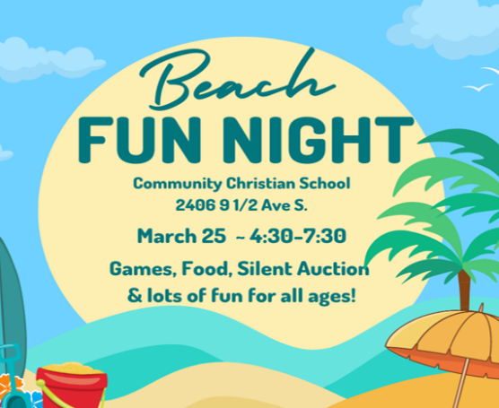

February 21, 2023
CCS BEACH FUN NIGHT
SATURDAY, MARCH 25th
4:30 – 7:30 pm – CCS GYMNASIUM
K8-AFTER SCHOOL-DAYCARE-PRESCHOOL BILLING: PLEASE check your email weekly for invoices related to your child. Invoices are sent from ccsbillingfd@gmail.com. Childcare invoices, after school invoices, preschool tuition invoices (3s) and K8 tuition all come from this email address. You are responsible for checking your email and paying these invoices in a timely fashion to avoid late fees. For any questions, please contact Sarah @ ccsbillingfd@gmail.com

BOOK FAIR SAVE-THE-DATE: It is time to get excited. The CCS Book Fair will be back this year during spring Parent Teacher conferences. More information on conferences and the book fair will be in the next memo.
3 & 4 YEAR OLD PRESCHOOL REGISTRATION: CCS Fall 2023 preschool registration is OPEN
If you are interested or know of a family interested in having their child attend preschool at CCS next fall, please contact the office via email (ccsofficefd@gmail.com) or phone (573-3011) and request a registration packet. Space is limited and applications are taken on a first-come, first-serve basis. Tell your friends and family to register early.

CCS KINDERGARTEN ROUND UP: If you are interested or know of a family interested in having their child attend kindergarten at CCS next fall, please contact the office via email (ccsofficefd@gmail.com) or phone (573-3011) and register for a spot on Friday, February 24th, at 3:30 or 5:30 pm to learn more about CCS. Space is limited and applications are taken on a first-come, first-serve basis. Tell your friends and family to register early for a spot.
CCS FAMILY ENGAGEMENT: CCS will have a school wide Family Engagement activity, Monday, March 6th. Our teachers and students will be meeting with parents in each grade level to explain the FASTBridge assessment results. We will also share strategies with parents that can be done at home to help students become stronger readers. Family Engagement will be approximately 30 minutes long, held in the Chapel – enter via either door (you will be buzzed in). We are looking forward to reading with you!
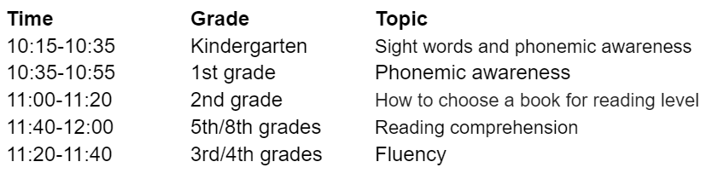
CCS BEACH FUN NIGHT 2023: Attached is a flyer for our Spring 2023 fundraiser... CCS BEACH FUN NIGHT - it’s time to get EXCITED (TONS OF FUN AHEAD - SPREAD THE WORD, THIS IS OPEN TO THE PUBLIC)!!!
CCS BEACH NIGHT FUN SILENT AUCTION ITEM DONATIONS: How exciting would it be to have over 100 auction items available to bid on at our upcoming fundraiser in March? SUPER EXCITING I’d say!! We are hoping that EACH Crusader family will be willing to drop off one silent auction item for the CCS BEACH FUN NIGHT the week of the event on March 25th. Families are encouraged to use their unique personal connections with businesses, relatives, or friends to come up with their family’s one item(s) to bring in. (Example items: themed baskets, unique experiences, local services, sports tickets, apparel, staycations, boy/girl themed items, etc.) These can be brought to the office (starting March 20th) along with the Silent Auction Drop-Off form attached.
BEACH FUN NIGHT WRISTBAND PLEDGE SHEETS: THESE WILL BE PASSED OUT IN MARCH!! WATCH FOR THE ANNOUNCEMENT. This is a great opportunity for families, friends, grandparents, aunts/uncles, and others to help raise funds for our students to have an unlimited wristband for all of the fun activities on CCS Beach Fun Night
MARCH MENUS: Attached are the March menus (only 2 more months of menus… oh my!!!)
FDSH – SYDNEY BECK VISIT (8th Grade Students): Friday, February 24th at 9am, Sydney Beck will be here from FD Senior High to chat with our 8th grade students about student life in high school and the registration process. FDSH is also hosting Family Night for 8th grade students and their families on Tuesday, February 28th at 6pm in the Senior High Gymnasium. At Family Night, they will be holding sessions that include information on graduation requirements, activities/clubs, student supports/resources, and general academic information. Student Ambassadors will be providing tours of the building throughout the night.

READ ACROSS AMERICA – DR SEUSS BIRTHDAY: March 3rd, we will be celebrating Dr Seuss and Read Across America. Students are welcome to dress up as their favorite Dr Seuss character that Friday. We will have guest readers in the classrooms, individual activities by class and a lot of exciting things to read in celebration.
SCHOOL CLOSINGS: With snowy days underway, please be aware that school delays or cancellations will be announced via text through our REMIND system, then be announced on WHO, KCCI, WOI, KJYL, KIAQ, KWMT, KICB, KVFD, KTLB, KXFT, KZLB & Facebook. We follow the Fort Dodge public & parochial school system in snow/ice delays, early outs and school cancellations (except for heat). If school is delayed, 3yr old & 4yr old morning preschool will be cancelled. If an early dismissal is called, there will be no 4 yr old afternoon preschool. Unless otherwise notified, CCS daycare will be open if staff is able to safely reach work. Breakfast available on late-start days for daycare kiddos.

DATES TO REMEMBER:
Feb 21 CCS Property & Finance Meeting – 6:30 pm
Feb 23 Kindergarten Round Up (register for a spot, 3:30 or 5:30 session)
Feb 24 Sydney Beck visit – 8th grade @ 9:00 am
Feb 27 CCS School Board Meeting – 6:30 pm
Feb 27 ICCC Dental Students visit CCS 7/8th – 8:15 am
Feb 28 Family Night (8th grade students/families) – 6:00 pm FDSH Gym
LOOKING AHEAD:
Mar 3 Dr Seuss’s Birthday & Read Across America
Mar 6 2 hour late start (professional development)
Mar 6 Family Engagement Activity (see schedule in memo for individual class times)
Mar 13-17 No School - Spring Break (all grades including 3 & 4 preschool)
Mar 13 CCS PTF (Booster) Meeting – 7:00 pm
Mar 14 CCS Marketing Meeting - noon
Mar 21 CCS Property & Finance Meeting – 6:30 pm
Mar 24 End of the 3rd Quarter
Mar 25 Kiwanis Pancake Breakfast - CCS gym 7am-noon
Mar 25 CCS Beach Fun Night – CCS gym 4:30-7:30pm
Mar 27 CCS School Board Meeting – 6:30 pm
Mar 28 & 30 Early Dismiss (1:00p) – Parent/Teacher Conferences
Mar 31 No School – Comp Day

BIBLE MEMORY VERSE FOR THE WEEK: REVIEW WEEK
COMMUNITY CHRISTIAN SCHOOL ● 2406 9 ½ Ave S ● Fort Dodge, Iowa 50501
www.ccsfd.org ● 515-573-3011 ● ccsofficefd@gmail.com
CCS MISSION: “Serving God by providing families an academically-excellent, Biblically-integrated education, which encourages spiritual development and social responsibility in an environment where students can develop their God-given gifts and talents.”

