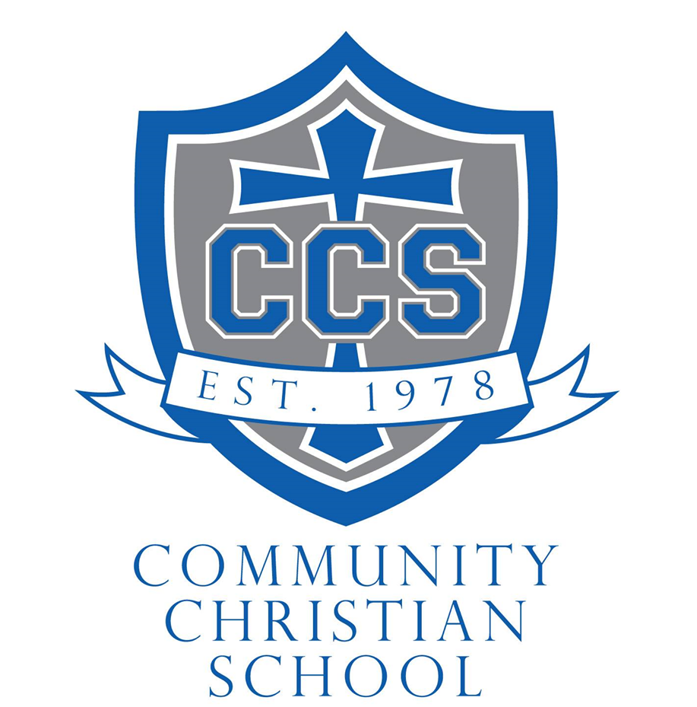

2023-2024
COMMUNITY CHRISTIAN SCHOOL
ATHLETIC HANDBOOK

I. COMMITMENT

Athletics at Community Christian School is an integral part of the overall school program and requires commitment from parents, coaches, teachers, and student athletes. Christian witness and testimony can and should be exemplified through participation, coaching, and fan support. Our athletic program is one of several means of developing the total Christian and is an honor and privilege for all participants. These extra-curricular activities add to education by promoting good citizenship and character, developing discipline for personal success, and promoting the image and identity of our school, community of Fort Dodge, and the Christian community at-large.

II. PHILOSOPHY OF ATHLETICS

Community Christian School student athletes should strive to be as much like Christ, with the Holy Spirit’s help, as possible, both on and off the court or field. Just as Jesus gave Himself for us (Phil. 2:8 – And being found in human form, he humbled himself by becoming obedient to the point of death, even death on a cross.), so should we work to give all we have to Him.
Scriptural-based character qualities promoting excellent athletics habits through practice and prayer:
- Dependability—Be at all practices and contests unless excused by your coach. Do what is expected of you in all situations. (Psalms 15:4b – but honors those who fear the Lord; who keeps an oath even when it hurts, and does not change their mind.)
- Punctuality—Be on time, never late! (Ecclesiastes 3:1 – For everything there is a season, and a time for every matter under heaven.)
- Love—Be self-sacrificing and show a real concern for team members, coaches, and opponents. (I Corinthians 13:3 – If I give away all I have, and if I deliver up my body to be burned, but have no love, I gain nothing.)
- Enthusiasm—Take an interest in every part of your sport and be glad to quickly carry out every part of the job. (I Thessalonians 5:15 – See that no one repays anyone evil for evil, but always seek to do good to one another and to everyone.)
- Faith—Show that you know the Lord is in control of all circumstances and that He is carrying out His will in your life. (Hebrews 11:1 – Now faith is the assurance of things hoped for, the conviction of things not seen.)
- Humility—Show forth the attitude that God is the one responsible for your abilities, talents, and success. (Philippians 2:3 – Do nothing from selfish ambition or conceit, but in humility count others more significant than yourselves, James 4:6b – God opposes the proud but gives grace to the humble)
- Endurance—Be able to withstand stress, hard work, and challenges that all Christian athletes experience. (Galatians 6:9 – And let us not row weary of doing good, for in due season we will reap)
- Boldness—Be ready to boldly express what Jesus Christ has done for you. Never give up. (Acts 4:29b – grant to your servants to continue to speak your word with all boldness)
- Self-control—Do not be boastful or envious of one another. (Galatians 5:25 – Let us not become conceited, provoking one another, envying one another)

III. CODE OF CONDUCT

Student athletes participating in any activities on campus or off campus that are inappropriate, illegal, or in violation of school rules may lose eligibility. Student athletes, coaches, parents, and spectators are expected to live in a way that is pleasing to the Lord at all times. A signed Code of Conduct form is required from each student athlete family prior to the first competitive game. Athletic contests are competitive; however, all present on behalf of Community Christian School athletics are expected to speak and ACT as a matter of Christian testimony in all situations.
IV. ACADEMIC ELIGIBILITY

Community Christian School desires all athletes to perform to their own highest potential in attitude, aptitude, and academics. In an effort to help teachers, coaches, and parents understand the policy better, it has been decided that any student involved in extracurricular activities must adhere to a responsible academic standard.
Firstly, the student should be current in all subjects. This includes Bible, Music, and Art. Eligibility periods will run from Monday to Monday. Any incompletes for any class may result in the student being ineligible until the following eligibility period.
Secondly, any student having a D+ or lower, or the equivalent of that grade, in any subjects will not be eligible until that grade has been raised to a C- or higher. The teacher, the parents, and the student will work together to accomplish this goal in a reasonable/timely manner.
Thirdly, it is the student's responsibility, along with the help of their instructors, to be aware of their standing academically. If a student is in danger of becoming ineligible, the teacher will inform the parent of this fact.
Finally, the teachers will inform the coaches/advisors/parents on Mondays if a student is ineligible. As with all school endeavors, if there are any questions or concerns regarding the policy, please feel free to contact the school, the administration, or the teachers involved.
V. ATHLETIC PHYSICAL EXAMINATIONS

All student athletes must have an up-to-date completed physical examination form on file at the CCS office prior to their first practice. Students are also required to have a medical treatment permission slip turned in before the first practice. (The Medical Release card for CCS should be taken by the athletic director to all CCS games.) NO student (including home-schooled students) may participate without these items on file. If possible, physicals will be offered at the school by a certified doctor. If any student is not present for the school physical, or has a pre-existing condition, he or she is responsible for getting a physical elsewhere.
VI. ATHLETIC FEE
This non-refundable $30 fee will be assessed for each student at the beginning of each season for students in 4th- 8th grade athletics. This is to be paid to the school office prior to the first practice. For athletes not associated with other CCS classes the fee may be increased up to $50 depending on the sport. The fee is to be utilized to help support the athletic program (hiring referees, upkeep of the gym floor, purchasing supplies, etc.)
VII. UNIFORM INFORMATION

Uniforms (including all equipment and attire for cheer & basketball) are purchased by and remain the property of CCS. Uniform conditions will be noted when issued and returned at the end of the season. Garment care and washing instructions (no hot water, allow to hang dry) must follow garment tagging. They are only to be worn for CCS sporting events. Damage to the uniform apart from participation in CCS athletics will be assessed to the student. Non-marking soles on shoes are required. Coaches may specify the color of socks, T-shirts, etc.
VIII. ATTENDANCE AT PRACTICES/GAMES

Practice sessions are specifically designed to develop skills, and athletes are expected to attend practice. These skills cannot be applied to contest situations if attendance at practice is not consistent. The coach reserves the right to limit playing time or assign additional workouts if any athlete misses a practice for any reason not approved in advance. The athlete must be in school at least ½ the school day on the day of a contest or practice to be eligible to participate unless they have an excused absence from the administrator.
Coaches will attempt to provide all student participants with an opportunity to participate at each game. It should be understood that play time will not be equal among players and may reflect participation during practice as well as overall ability. Younger students, and their parents, should understand that preference will typically be given to older students, but each child will be valued and recognized for their contributions.

IX. DRESS CODE FOR ATHLETES (Games: Home & Away, Practice)

On game day, students are required to wear the CCS-issued game day shirt to school with khakis, black pants, or black nylon sport pants. They should also wear this attire while traveling and while in attendance at the game site to show team unity. Students may wear chapel dress, or other clothing in lieu of the above if approved by the administrator. For practice, students are required to wear appropriate, modest sportswear and tennis shoes.

X. CONCUSSION PRECAUTION

Senate file 367 requires a parent or guardian to sign and return a concussion and brain injury information sheet prior to the student practicing or participating in any extra-curricular interscholastic activity for grades 7-12. Coaches are required to remove a student who shows signs of a concussion or brain injury from the activity until the student receives written clearance from a licensed healthcare provider.

XI. ATHLETIC AWARDS CEREMONY

An athletic awards ceremony will be held following the season to honor all participants. Attendance is expected by student athletes and coaches. Chapel dress is required.
XII. SPORTS AWARDS

The coaches of each athletic/cheerleading team will determine all awards given and should meet prior to the awards ceremony with the athletic director to agree upon awards. Awards should be positive and encouraging in nature and reflective of athletic ability, performance, and potential and may include trophies, letters, pins, certificates, or other ways to signify accomplishment.
Coaches’ gifts are given at the sports awards ceremony by the athletic director and should be nominal in nature or based mostly on donations provided by athletic families. CCS Athletics will offer a $50 base amount per coach should there not be adequate donations offered.
XIV. ATHLETIC FACILITIES USAGE

All facilities on the CCS property are designed for multiple school activities. Extreme care must be taken to assure that the next group using the facilities finds them clean, well-cared for, and vacated on time. The following regulations are in force:
- No student is permitted the use of any athletic facility at any time without the supervision of a staff member.
- The use of any school athletic equipment must be cleared through the athletic director or coach.
- Restrooms and changing facilities must be left neat and free from any items not in proper storage receptacles.
- VALUABLES MUST NOT BE LEFT IN UNSECURED LOCATIONS and should not be brought to games.
- The use of non-CCS facilities for practices and contests is subject to these regulations in addition to their regulations. Competitor facilities are to be left in good or better condition than when CCS players and fans arrived for use.

XV. TRANSPORTATION

Athletes are responsible for their own transportation to and from athletic practice, events, and games. Ride arrangements should be made in advance.
XVI. THE ATHLETIC COMMITTEE

The athletic committee will be composed at minimum of the athletic director, head coach of each sport, and school administrator. The athletic committee may meet as needed which may include before the season starts, during the season, and prior to the sports awards banquet. After that, they may meet as needed during the school year at a date and time determined by the athletic director &/or the committee.
XVII. EXCEPTIONS

Exceptions to the regulations set forth in this handbook may be made at the discretion of the athletic director and administration. Athletes not associated with other CCS classes may be eligible to participate in CCS athletics; however, this allowance will be made on a case by case basis following an interview with the athletic director to ensure participation is a good fit for all those involved including the athletes, coaches/staff, and opponents.

XVIII. ATTACHMENTS

Community Christian School Student Athlete Handbook Agreement
Iowa Athletic Pre-Participation Physical Examination Form (see website)
Heads Up: Concussion in High School Sports Form (see website)

Community Christian School Student Athlete Handbook Agreement
All athletes must have this signed and returned to the office before participating in athletics at CCS.
STUDENT ATHLETES:
I understand the 2023-2024 Student Athlete Handbook.
I commit to cooperation and philosophical support of its content as well as to adhere to the policies, standards, and guidelines as detailed in this handbook and as discussed at the Athlete/Parent Meeting.
_______________________________________ ______________________________________ Student’s Name (Please print) Grade
_______________________________________ ______________________________________ Student’s Signature Date
PARENT/GUARDIAN:
I understand the 2023-2024 Student Athlete Handbook.
I agree to partner with the coaches, faculty, and administration in upholding the rules and procedures outlined. I understand that these rules will be enforced in a fair and consistent manner. I understand that if I have concerns about my child, I need to contact the coach at the appropriate time. I also understand that if issues do not seem to be resolved, I then need to contact the athletic director and principal with my concerns.
In consideration for being allowed to participate in this Activity (CCS Athletics and associated programs), I release from liability and waive my right to sue CCS, their employees, officers, volunteers and agents (collectively “District”) from any and all claims, including claims of the District’s negligence, resulting in any physical injury, illness (including death) or economic loss I may suffer or which may result from my participation in this Activity, travel to and from the Activity, or any events incidental to this Activity. I am the parent or legal guardian of the Participant. I have read this document, and I am signing it freely. I understand the legal consequences of signing this document, including (a) releasing the District from all liability on my and the Participant’s behalf, (b) waiving my and the Participants’ right to sue the District, (c) and assuming all risks of Participant’s participation in this Activity, including travel to and from the Activity (including air travel) or any events incidental to this Activity. I allow the Participant to participate in this Activity. I understand that I am responsible for the obligations and acts of the Participant as described in this document. I agree to be bound by the terms of this document.
Additionally, I understand that it’s my responsibility to volunteer during games and the Pancake Breakfast fundraiser. I realize that in failing to volunteer I am giving permission to the athletic director to assign responsibilities to me.
________________________________________ ______________________________________ Parent’s Name (Please print) Child
________________________________________ ______________________________________ Parent’s Signature Date

